- Download Peter’s Assembly Language Simulator from Moodle, which is a zipped file.
- Extract the contents into a folder in your area.
- Double-click on Assembler.exe and the program will launch as shown below.

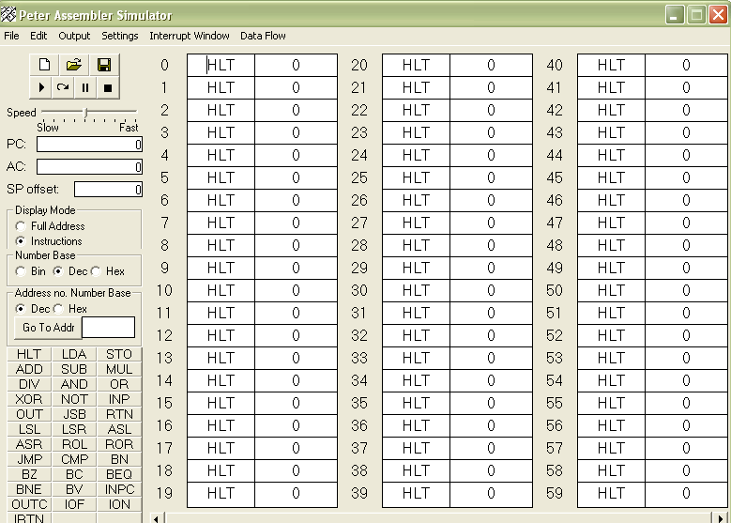
There is more in this application than you will need to know on this course. All you need to be able to use are the commands LOAD, ADD and STORE. The instructions used for these in the Peter Simulator are LDA, ADD, and STO.

This will be your first assembly language program:

LDA #8
ADD #6
STO 4

Add these lines of code to the boxes with the addresses 0,1 and 2. Press the Play button and note what happens. The result should be as shown in the figure below.

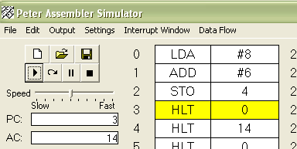 | What has happened?  8 has been LOADed into the accumulator  6 has been ADDed to it  The result has been STORED in location 4.  The # before a number means it is that actual number.  If there is not a # before the number then the number refers to the location or address.

Now carry out these exercises using the Peter Simulator:

- Enter the following code:

LDA #0
ADD #3
STO 10
ADD #3
STO 11
ADD #3
STO 12

What does this program do? Check with your neighbour that you get the same results.

- Write a program to add 25 to 17 and put the answer in location 12.
- Write a program to subtract 20 from 43 and put the answer in location 13.
- Write a program which:
- adds 15 to 33 then puts the answer into location 22,
- then adds 8 to 3 and put the contents in location 23,
- then adds the contents of both locations together and puts them into location 24.
- Set the contents of memory locations as follows :

Memory Location | Value
50 | 40
51 | 160
52 | 30

Write a program which:
- adds the contents of locations 50,51, and 52 together and stores the total in memory location 59.
- Check after running the program that memory location 59 contains your expected result.

- Experiment with the INP (input) and the OUT (output) commands. Use INP to ask the user to enter a number, then add 10 to it and output the result.

